Exercise 05:
Question:
Develop a 5-page research proposal that systematically outlines a research plan for a topic of your interest, demonstrating your understanding of key methodological components.
Solution:
“Real-Time Gait Abnormality Detection Using Inertial Sensors and Explainable AI Techniques”

Principal Investigator:
Bharathwaj Manoharan.
Department of Electronics and Instrumentation Engineering
SRM INSTITUTE OF SCIENCE AND TECHNOLOGY

Email:
Phone:
Date of Submission:

Signatures:

Principal Investigator : ________________________

Head of Department : ________________________

TABLE OF CONTENTS:

Sl. No. | Topic | Remarks
1 | Abstract
2 | Introduction
3 | Aim
4 | Objectives
5 | Literature Review
6 | Methodology
7 | System Architecture / Block Diagram
8 | Hardware and Software Requirements
9 | Expected Outcomes
10 | Budget Estimate
11 | Timeline and Deliverables
12 | Team Composition
13 | Feasibility and Risk Analysis
14 | Funding Agency Details
15 | References
16 | Annexures
17 | Declaration
- ABSTRACT:
The proliferation of wearable sensor technology has opened new frontiers in the continuous monitoring of neurodegenerative disorders, yet the clinical adoption of these technologies remains hampered by the "black-box" nature of advanced machine learning algorithms. This project proposes the development of a robust, non-invasive gait monitoring system capable of detecting abnormalities such as Freezing of Gait (FoG), ataxia, and prodromal fall patterns in real-time. While Deep Learning (DL) models, particularly hybrid architectures combining Convolutional Neural Networks (CNN) and Long Short-Term Memory (LSTM) networks, have demonstrated superior accuracy in classifying complex human activities, they fail to provide the interpretability required for medical intervention. This research seeks to bridge the critical gap between high-performance predictive modeling and clinical transparency by integrating Explainable AI (XAI) techniques, specifically SHapley Additive exPlanations (SHAP) and Layer-Wise Relevance Propagation (LRP), into the diagnostic pipeline.
The proposed system utilizes a distributed IoT architecture, employing ESP32 microcontrollers interfaced with MPU6050 inertial sensors to capture tri-axial acceleration and angular velocity at the edge. A dual-stage processing framework is envisioned: a lightweight, quantized model deployed on the edge for immediate hazard flagging, and a server-side high-fidelity model for detailed biomechanical interpretation. The research will rigorously evaluate the trade-offs between model complexity, inference latency, and the fidelity of generated explanations. By validating the system against both benchmark datasets and experimentally collected field data, this project aims to deliver a prototype that not only flags when a gait abnormality occurs but visualizes why—identifying specific kinematic features and gait phases driving the diagnosis. This contributes directly to the development of trustworthy assistive technologies that empower clinicians with actionable, understandable data, aligning with national priorities for digital healthcare innovation.
- INTRODUCTION:

- Background and Motivation:

The quantitative analysis of human gait has transitioned from the confines of high-end motion capture laboratories to the ubiquity of the real world, driven by the miniaturization of Micro-Electromechanical Systems (MEMS). Gait is a complex, rhythmic motor task that serves as a sensitive biomarker for the integrity of the nervous system. Deterioration in gait mechanics is often the first indicator of neurodegenerative progression in conditions such as Parkinson’s Disease (PD), Multiple Sclerosis, and post-stroke recovery. In particular, Freezing of Gait (FoG)—a transient inability to generate effective stepping—afflicts a significant proportion of advanced PD patients, leading to falls, fractures, and a severe reduction in quality of life.

Conventional clinical assessments, such as the Unified Parkinson’s Disease Rating Scale (UPDRS), rely heavily on subjective observation during episodic clinic visits. These snapshots often fail to capture the intermittent and context-dependent nature of gait disturbances that occur in daily life. Optical motion capture systems (e.g., Vicon), while considered the gold standard, are prohibitively expensive, immobile, and require expert operation, rendering them unsuitable for longitudinal home monitoring. Consequently, there is a compelling clinical imperative for wearable solutions that can continuously monitor gait kinematics in free-living environments.

The advent of Deep Learning (DL) has revolutionized the processing of Inertial Measurement Unit (IMU) data. Unlike traditional machine learning which requires laborious manual feature engineering, DL models such as Convolutional Neural Networks (CNNs) and Recurrent Neural Networks (RNNs) can automatically learn hierarchical representations of motion from raw sensor data. Recent studies utilizing hybrid CNN-LSTM architectures have reported classification accuracies exceeding 98% for gait abnormalities. However, this performance comes at the cost of opacity. In a clinical setting, a "black-box" algorithm that predicts a fall risk without biomechanical justification is often viewed with skepticism. If a model flags a gait cycle as "pathological," the clinician must understand whether this decision was driven by asymmetry in stride length, bradykinesia (slowness of movement), or tremor-induced noise. The integration of Explainable AI (XAI) is thus not merely a technical enhancement but a fundamental requirement for the ethical and practical deployment of AI in healthcare.

- Scope of the Project:
The scope of this project extends beyond simple activity classification to encompass the end-to-end design of an interpretable diagnostic instrument.
- Hardware Implementation: The project involves the fabrication of a strap-down wearable node using the ESP32 microcontroller, chosen for its dual-core processing capabilities and energy efficiency compared to single-board computers like the Raspberry Pi in battery-constrained scenarios.
- Algorithmic Innovation: The core computational effort focuses on developing a hybrid CNN-LSTM model. The CNN component handles spatial feature extraction (correlations between accelerometer and gyroscope axes), while the LSTM component captures the temporal dependencies inherent in the gait cycle.
- Explainability Framework: A significant portion of the research allows for the integration of post-hoc interpretability methods. We will adapt SHAP and Grad-CAM algorithms for time-series data to visualize feature importance, effectively mapping "relevance scores" back to specific phases of the gait cycle (e.g., heel strike, toe-off).
- Validation and Testing: The system will be validated using public datasets (e.g., PhysioNet, OU-ISIR) and locally collected data, assessing metrics such as F1-score, latency, and the "Trustworthiness" of the XAI outputs.
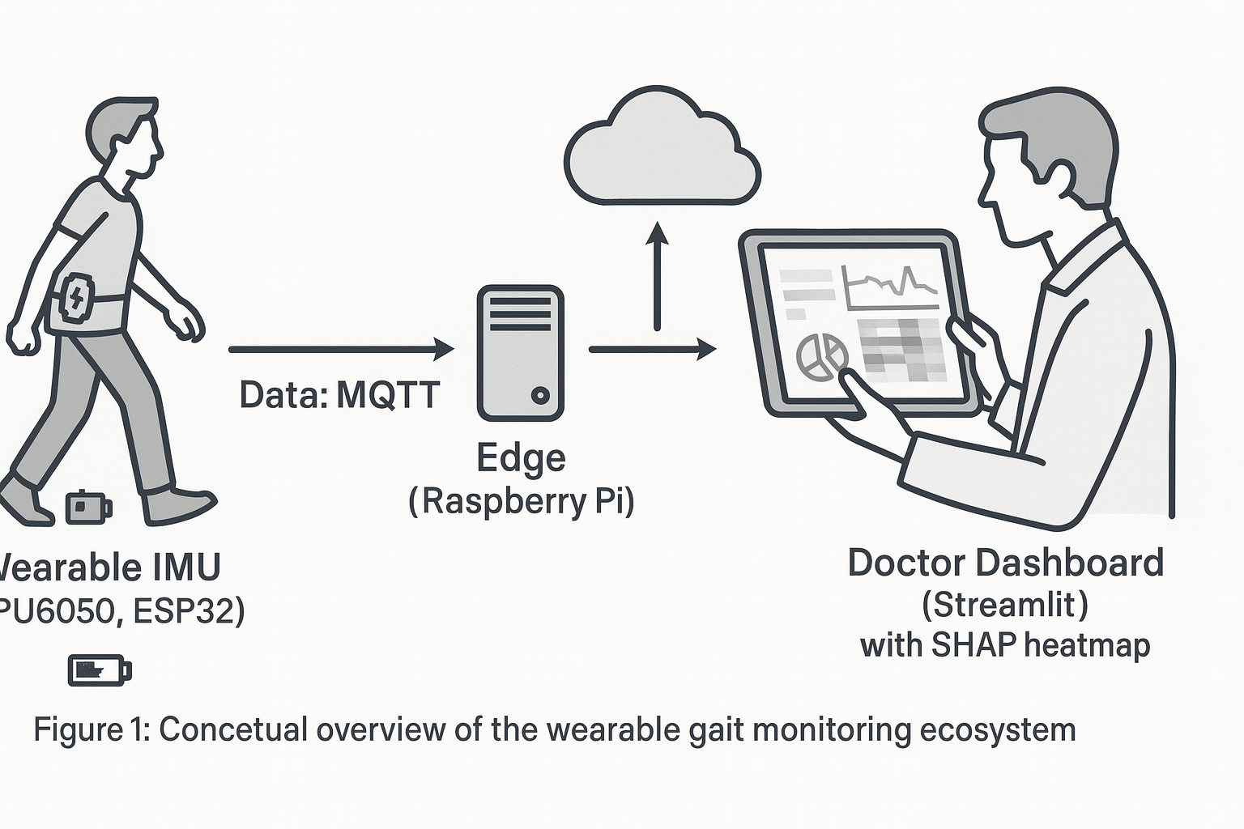
- Research Questions:
The investigation is driven by the following critical inquiries:
- Optimization of Hybrid Architectures: How can the hyper-parameters of a CNN-LSTM model (kernel size, window overlap, LSTM units) be optimized to maximize sensitivity to subtle gait deviations like festination while minimizing false positives caused by voluntary movements?
- Signal Fidelity in Low-Cost Sensors: Can robust preprocessing techniques (e.g., adaptive Butterworth filtering, sensor fusion) sufficiently mitigate the drift and noise inherent in low-cost MEMS sensors (MPU6050) to achieve clinical-grade accuracy?
- Interpretability in Time-Series: How can model-agnostic XAI methods be computationally optimized to provide granular explanations (e.g., identifying that the Z-axis acceleration at t=200ms was the deciding factor) without prohibitive processing delays?
- Edge vs. Cloud Partitioning: What is the optimal distribution of computational load between the wearable edge node and the central server to ensure real-time alerts for falls while preserving battery life for long-term monitoring?

- Relevance to National Priorities:
This project is strategically aligned with the Digital India and Make in India initiatives, aiming to foster indigenous capacity in high-value medical electronics. It directly addresses the objectives of the Department of Science & Technology (DST) TIDE scheme (Technology Interventions for Disabled and Elderly), which prioritizes R&D in assistive devices that enhance the autonomy and quality of life for the elderly and disabled populations. By reducing the reliance on imported, expensive gait analysis systems, this research contributes to the democratization of advanced healthcare diagnostics in resource-constrained settings.
- AIM:
To design, calibrate, and deploy a wearable gait analysis system that leverages the synergy of high-precision inertial sensing, deep learning-based pattern recognition, and explainable artificial intelligence to detect and interpret gait abnormalities with high fidelity in real-time environments.
- OBJECTIVES:
The project is broken down into five tangible objectives:
- Hardware Design and Sensor Fusion: To engineer a compact, wireless wearable node integrating the ESP32 microcontroller and MPU6050 6-DoF IMU. This includes implementing sensor fusion algorithms (Complementary or Kalman Filter) to combine accelerometer and gyroscope data for drift-free orientation estimation.
- Robust Data Preprocessing: To develop a signal processing pipeline that employs sliding-window segmentation (e.g., 2-second windows with 50% overlap) and frequency-domain filtering (4th order Butterworth) to standardize inputs for neural network training.
- Hybrid Model Development: To implement and train a CNN-LSTM neural network architecture capable of distinguishing between normal gait, simulated pathological gait (e.g., FoG, shuffling), and static activities with an accuracy target exceeding 90%.
- Implementation of Explainable AI: To integrate SHAP (Shapley Additive exPlanations) to quantify the marginal contribution of each sensor feature to the model's prediction, providing visual "force plots" that highlight the temporal location of gait anomalies.
- System Validation and Benchmarking: To systematically evaluate the prototype against established datasets (e.g., Daphnet FoG) and real-world trials, analyzing the computational latency and energy consumption to ensure feasibility for daily usage.

- LITERATURE REVIEW:
The domain of gait analysis has witnessed a paradigm shift from observational heuristics to data-driven precision medicine. This review synthesizes key developments in sensor technology, deep learning architectures, and the emerging field of Explainable AI in healthcare.
- Evolution of Wearable Gait Analysis Early gait analysis relied on pressure-sensitive mats or laboratory-based optical trackers. While accurate, these systems failed to capture the " Hawthorne effect," where patients alter their walking patterns when observed in a clinical setting. The introduction of MEMS-based Inertial Measurement Units (IMUs) enabled continuous, unobtrusive monitoring. Research by Chen et al. demonstrated the efficacy of single-sensor approaches for estimating walking gait in construction workers, validating that a single waist or foot-mounted IMU can capture sufficient kinematic data for basic gait profiling. However, single-sensor systems often struggle with complex activity recognition compared to multi-sensor networks, though they offer significant advantages in user compliance and battery life.
- Deep Learning Architectures: The Rise of Hybrids The transition from manual feature extraction (calculating mean, variance, entropy) to automatic feature learning has defined the last decade of research. Bikias et al. introduced DeepFoG, a deep learning framework utilizing a 2-layer CNN to detect freezing episodes in Parkinson's patients with 88% specificity. Their work highlighted that CNNs are exceptionally good at extracting local spatial features (e.g., the sudden high-frequency vibration of a tremor) but may miss the temporal context of the gait cycle history. To address this, Hybrid CNN-LSTM models have emerged as the state-of-the-art. Agarwal et al. (2025) proposed a dual-branch CNN-LSTM framework that processes joint-based features and silhouette sequences simultaneously. The CNN layers act as feature extractors, feeding abstract representations into LSTM layers that model the time-dependencies of the gait cycle. This architecture achieved 98.6% accuracy on benchmark datasets, confirming that combining spatial convolution with temporal recurrence yields superior performance over either architecture alone. Hasan et al. further refined this by introducing modified residual blocks to lightweight CNNs, enabling high-accuracy gait recognition on resource-constrained devices like the Raspberry Pi, a critical consideration for wearable deployment.
- The Interpretability Imperative (XAI) Despite predictive success, the opacity of DL models remains a critical barrier. Alharthi (2024) conducted a comprehensive study using Layer-Wise Relevance Propagation (LRP) to analyze gait deterioration. Their findings demonstrated that XAI could pinpoint specific biomechanical features—such as variations in foot-ground reaction forces—that distinguished Parkinsonian gait from healthy dual-tasking gait. This capability to visualize "relevance" transforms the AI from a black box into a clinical decision support tool. Similarly, studies applying SHAP to time-series data have successfully identified specific gait events, such as the heel-contact phase, as the primary drivers for classification, aligning algorithmic "attention" with biomechanical reality.
- Hardware and Edge Computing The implementation of these complex models requires careful hardware selection. While Dion et al. (2024) proposed in-sensor computing to reduce power consumption, standard implementations still rely on microcontrollers. The ESP32 is widely favored over the Raspberry Pi for the sensing node due to its integrated Wi-Fi/Bluetooth, dual-core architecture, and significantly lower power profile. However, for the heavy lifting of SHAP value calculation, edge-server architectures (using a Raspberry Pi 4 or Jetson Nano as a gateway) remain the standard approach to balance latency and computational depth.
- Research Gap While individual studies have addressed deep learning for gait (DeepFoG) and offline explainability (Alharthi), there is a paucity of research integrating hybrid CNN-LSTM architectures with real-time explainability pipelines on low-cost hardware. Most XAI implementations are computational heavyweights, run offline on powerful workstations. This project aims to demonstrate a practical workflow where real-time detection is immediate, while interpretable insights are generated asynchronously for clinical review, optimizing the trade-off between speed and transparency.

- METHODOLOGY:
The research design follows a systematic, multi-phase approach, ensuring rigorous validation at each stage of the development lifecycle.
Stage 1: Requirement Analysis and Sensor Characterization
The initial phase involves defining the signal acquisition parameters. Human gait frequencies typically range between 0.5 Hz and 3 Hz, with pathological tremors (e.g., in PD) extending up to 5–8 Hz. According to the Nyquist-Shannon sampling theorem, a sampling rate of at least 20 Hz is required; however, to capture transient events like heel strikes and micro-tremors with high fidelity, a sampling rate of 100 Hz is selected.
- Sensor Selection: The MPU6050 (6-DoF) is selected for its cost-effectiveness. While 9-DoF sensors like the BNO055 offer magnetometer data for absolute heading, magnetic interference in indoor environments often degrades data quality. For gait dynamics (which are largely inertial), the 6-DoF configuration is sufficient and more robust against environmental noise.
- Calibration: Static calibration routines will be implemented to calculate and subtract zero-g offsets for the accelerometer and zero-rate drift for the gyroscope.
Stage 2: Signal Preprocessing and Segmentation
Raw IMU signals exhibit high-frequency noise and drift, necessitating preprocessing steps such as filtering, bias correction, and normalization prior to neural-network ingestion.
- Filtering: A 4th-order Butterworth low-pass filter with a cut-off frequency of 20 Hz will be applied. This specific cutoff is chosen to attenuate high-frequency sensor noise and mains hum (50Hz) while preserving the kinematic content of voluntary movement and pathological tremors.
- Sliding Window Segmentation: Continuous time-series data will be segmented into fixed-width windows. Based on literature optimizing for CNN-LSTM inputs, a window size of 2 seconds (200 samples) with a 50% overlap is chosen. This duration captures approximately two full gait cycles, providing sufficient temporal context for the LSTM layers to identify periodicity, while the overlap ensures continuity and prevents edge effects.
- Normalization: Z-score normalization (standardization) will be applied to each sensor axis independently to ensure that the model converges faster and is not biased by the differing scales of acceleration (g) and angular velocity (deg/s).
Stage 3: Hybrid Model Development (CNN-LSTM)
The core classification engine utilizes a hybrid architecture designed to exploit the strengths of both convolutional and recurrent networks:
- Input Layer: Accepts tensors of shape (N, 200, 6) representing the windowed 6-axis IMU data.
- Spatial Feature Extraction (CNN): Two 1D Convolutional layers (filters=64/128, kernel size=3) with Rectified Linear Unit (ReLU) activation. These layers scan the time series to detect local patterns such as sudden peaks (heel strikes) or tremors. Max Pooling layers follow the convolutions to down-sample the data and reduce computational load.
- Temporal Modeling (LSTM): The flattened feature maps from the CNN are fed into two stacked LSTM layers (units=128/64). The LSTM cells maintain an internal state, allowing the network to learn the sequence of gait phases (e.g., swing follows stance). This is crucial for detecting anomalies where the sequence is disrupted, such as in festination
- Classification Head: A Fully Connected (Dense) layer with Softmax activation outputs probabilities for classes: Normal Walking, Freezing of Gait, and Stopped.
- Spatial Training Protocol: The model will be trained using the Adam optimizer and Categorical Cross-Entropy loss function. Techniques like Dropout (rate=0.5) will be employed to prevent overfitting.
Stage 4: Explainability Implementation (XAI)
To render the "black box" transparent, SHAP (SHapley Additive exPlanations) will be implemented.
- Method: KernelSHAP or DeepSHAP will be used to approximate the Shapley values for each feature in the input window.
- Interpretation: The output will be visualized as "Force Plots" or heatmaps overlaid on the raw signal. For instance, if the model predicts "FoG," the SHAP plot might highlight a high-frequency oscillation in the Gyroscope-Z axis, validating that the model is correctly identifying the tremor associated with freezing rather than an artifact.
- Optimization: Since SHAP is computationally expensive, we will explore "segmentation" strategies where SHAP values are calculated for blocks of time rather than individual time steps to reduce processing time without sacrificing interpretability.
Stage 5: System Integration and Testing
The trained model will be quantized (using TensorFlow Lite) for efficient execution.
- Data Flow: The ESP32 will stream preprocessed data via MQTT (Message Queuing Telemetry Transport) over Wi-Fi to a local edge server (Raspberry Pi 4). The RPi will host the DL model and the XAI engine.
- Dashboard: A Python-based dashboard (Streamlit) will subscribe to the MQTT topic, visualizing the real-time gait waveform, the classification result, and—on demand—the SHAP explanation for the most recent anomaly.

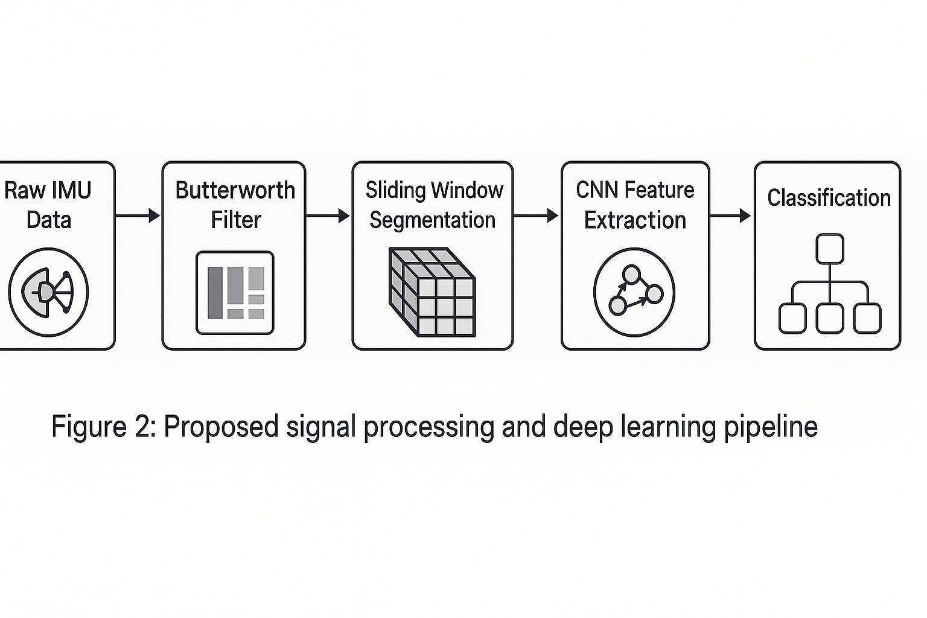

- EXPECTED OUTCOMES:

- Validated Prototype: A fully functional, strap-down wearable device capable of streaming high-fidelity inertial data (100Hz) wirelessly without packet loss in a standard room environment.
- High-Accuracy Classifier: A trained hybrid CNN-LSTM model that demonstrates a classification accuracy of >90% and an F1-score of >0.88 on test datasets, effectively distinguishing between normal gait, Freezing of Gait (FoG), and idling, comparable to state-of-the-art models like DeepFoG.
- Clinical Interpretability: A novel software module that successfully outputs SHAP-based visualizations. The outcome will be verified if the module can correctly highlight known biomechanical markers (e.g., identifying high-frequency tremors in the Z-axis during a simulated freeze) as the reason for a positive diagnosis.
- Annotated Dataset: A labeled dataset comprising raw IMU data from volunteer trials (simulating gait abnormalities), which will be valuable for future research in semi-supervised learning.
- Latency Benchmarks: A performance report detailing the inference time (aiming for <500ms for detection) and the additional latency introduced by the XAI module, establishing the feasibility of real-time explanation.

- BUDGET ESTIMATE:
The budget is meticulously calculated based on current market prices in India for the fiscal year 2024-2025. It prioritizes cost-effectiveness while ensuring component quality.
Category | Item Description | Quantity | Unit Cost (₹) | Total Cost (₹) | Justification
Hardware | ESP32 Development Board (WROOM-32) | 2 | 350 | 700 | Main controller for wearable node.
 | MPU6050 Sensor Module (GY-521) | 3 | 150 | 450 | Primary inertial sensor (1 spare).
 | Raspberry Pi 4 Model B (8GB RAM) | 1 | 7,500 | 7,500 | Edge server for AI/XAI processing.
 | 3.7V Li-Po Battery (2000mAh) | 2 | 380 | 760 | Power source for wearable.
 | TP4056 Charging Module | 2 | 50 | 100 | Battery management.
 | BNO055 9-DoF Sensor (Optional) | 1 | 1,500 | 1,500 | For comparative validation (absolute orientation).
 | Prototyping (Breadboard, Wires, PCB) | - | - | - | Circuit assembly.
 | 3D Printing Materials (PLA/PETG) | - | - | - | Enclosure fabrication.
Software/Services | Cloud Server Credits (AWS/GCP) | - | - | 5,000 | Optional training of heavy models if local GPU is insufficient.
Manpower | Research Assistant / Data Collection | - | - | 25,000 | Stipend for data collection trials and labeling.
Contingency | Unforeseen expenses (shipping, repairs) | - | - | 3,290 | 10% buffer.
 | Total Estimated Budget |  |  | ₹ 46,300

Note: Although more advanced platforms such as the NVIDIA Jetson Nano (approximately ₹20,000–₹23,000) provide significantly stronger GPU acceleration for edge-based AI—especially beneficial for medical imaging and real-time inferencing—the Raspberry Pi 4 is chosen here to maintain a lower overall cost while still offering sufficient CPU performance for lightweight medical AI workloads. The budget also leaves room for upgrading to a GPU-accelerated platform if project requirements increase.
- TIMELINESS & DELIVERABLE:

Phase | Duration (Months) | Activities | Deliverables
Phase I | 0 – 2 | Literature Review & System Design: Analyzing recent papers (Alharthi 2024, Bikias 2021), selecting components, and finalizing the CNN-LSTM architecture. | System Architecture Document, Component Procurement List.
Phase II | 3 – 4 | Hardware Assembly & Firmware: Interfacing ESP32 with MPU6050, writing I2C drivers, implementing MQTT transmission, and power optimization (Deep Sleep testing). | Functional Data Logging Prototype, Firmware Codebase.
Phase III | 5 – 7 | Data Collection & Preprocessing: Conducting walking trials, performing accurate data labeling, and applying the Butterworth filter with a streamlined sliding-window pipeline for clean, well-structured data. | Raw and Cleaned Datasets, Preprocessing Python Scripts.
Phase IV | 8 – 9 | Model Training & Optimization: Training the hybrid CNN-LSTM model. Hyperparameter tuning (kernel sizes, LSTM units). Evaluating accuracy vs. latency. | Trained Model Weights (.h5/.tflite), Performance Metrics Report.
Phase V | 10 – 11 | XAI Integration & Dashboard: Implementing SHAP algorithms. Developing the Streamlit dashboard to visualize real-time data and "Force Plots". | Explainability Module, Interactive User Interface.
Phase VI | 11 – 12 | Validation & Reporting: Final system testing, documenting results, writing the thesis, and preparing for demonstration. | Final Thesis/Report, Operational Prototype Demo.

- TEAM COMPOSITION:

- Principal Investigator (PI): Responsible for the overall project vision, architectural design, and ensuring the research aligns with clinical explainability standards (Abdullah Alharthi's guidelines).
- Co-Investigator: Focuses on the embedded systems aspect—optimizing the ESP32 firmware, sensor fusion algorithms (Kalman filtering), and power management.
- Research Assistant/Student: Tasked with data collection, manual labeling of gait phases, coding the neural networks (TensorFlow), and running the SHAP analysis.
- External Mentor (Optional): A physiotherapist or neurologist to provide domain expertise, validating that the "features" identified by the AI (e.g., stride time variability) are clinically relevant markers of disease.

- FEASIBILITY & RISK ANALYSIS:

- Technical Feasibility:
The project relies on mature, well-documented technologies. The ESP32 and MPU6050 are industry standards for IoT prototyping. The hybrid CNN-LSTM approach is robustly supported by recent literature. The primary technical challenge lies in the computational cost of SHAP for time-series; however, recent "segmentation" strategies make this feasible on server-class hardware (RPi 4 or Laptop).

- Risk Analysis & Mitigation:

Risk Category | Risk Description | Mitigation Strategy
Sensor Data | Drift & Noise: MEMS sensors suffer from integration drift over time. | Use sensor fusion (Complementary Filter) to combine Accelerometer and Gyroscope data. Perform regular static calibration.
Data | Data Scarcity: Obtaining real pathological data is difficult. | Use public datasets (PhysioNet, Daphnet) for pre-training (Transfer Learning), then fine-tune with simulated local data.
Computation | Latency: SHAP calculation is slow. | Decouple detection from explanation. Real-time detection runs instantly; XAI runs asynchronously (post-event).
Hardware | Battery Life: Wi-Fi transmission drains power quickly. | Implement data batching (send packets every 1s instead of continuous stream) or switch to ESP-NOW/BLE if critical.
Model | Overfitting: Model memorizes specific subjects. | Use "Leave-One-Subject-Out" (LOSO) cross-validation during training to ensure generalization.

- REFERENCE:

[1] A. S. Alharthi, “Interpretable machine learning comprehensive human gait deterioration analysis,” Frontiers in Neuroinformatics, vol. 18, 2024.
[2] T. Bikias, D. Iakovakis, S. Hadjidimitriou, V. Charisis, and L. J. Hadjileontiadis, “DeepFoG: An IMU-based detection of freezing of gait episodes in Parkinson’s disease patients via deep learning,” Frontiers in Robotics and AI, vol. 8, 2021.
[3] S. Chen, S. S. Bangaru, T. Yigit, M. Trkov, C. Wang, and J. Yi, “Real-time walking gait estimation for construction workers using a single wearable inertial measurement unit (IMU),” in Proc. IEEE/ASME Int. Conf. Advanced Intelligent Mechatronics (AIM), 2021, pp. 753–758.
[4] G. Dion, A. Tessier-Poirier, L. Chiasson-Poirier, J.-F. Morissette, G. Brassard, A. Haman, K. Turcot, and J. Sylvestre, “In-sensor human gait analysis with machine learning in a wearable microfabricated accelerometer,” Communications Engineering, vol. 3, no. 1, p. 48, 2024.
[5] M. A. M. Hasan, F. Al Abir, M. Al Siam, and J. Shin, “Gait recognition with wearable sensors using modified residual block-based lightweight CNN,” IEEE Access, vol. 10, pp. 42577–42588, 2022.
[6] W. Kim, Y. Kim, and K. Y. Lee, “Human gait recognition based on integrated gait features using Kinect depth cameras,” in Proc. IEEE 44th Annu. Computers, Software and Applications Conf. (COMPSAC), 2020, pp. 328–333.
[7] P. Limcharoen, N. Khamsemanan, and C. Nattee, “Gait recognition and re-identification based on regional LSTM for 2-second walks,” IEEE Access, vol. 9, pp. 112057–112068, 2021.
[8] M. I. Mamun, S. Hossain, and M. A. R. Ahad, “Explainable AI in healthcare: Interpretable detection of Parkinson’s disease from mobile-collected handwriting patterns,” in Proc. IEEE 4th Int. Conf. Computing and Machine Intelligence (ICMI), 2025, pp. 1–6.
[9] V. B. Semwal, N. Gaud, P. Lalwani, V. Bijalwan, and A. K. Alok, “Pattern identification of different human joints for different human walking styles using inertial measurement unit (IMU) sensor,” Artificial Intelligence Review, vol. 55, no. 2, pp. 1149–1169, 2022.
[10] C. Shen, S. Yu, J. Wang, G. Q. Huang, and L. Wang, “A comprehensive survey on deep gait recognition: Algorithms, datasets and challenges,” IEEE Transactions on Biometrics, Behavior, and Identity Science, 2023.
[11] L. F. Shi, Z. Y. Liu, K. J. Zhou, Y. Shi, and X. Jing, “Novel deep learning network for gait recognition using multimodal inertial sensors,” Sensors, vol. 23, no. 2, 2023.
[12] L.-F. Shi, C.-X. Qiu, D.-J. Xin, and G.-X. Liu, “Gait recognition via random forests based on wearable inertial measurement unit,” Journal of Ambient Intelligence and Humanized Computing, vol. 11, no. 11, pp. 5329–5340, 2020.
[13] B. Su, C. Smith, and E. G. Farewik, “Gait phase recognition using deep convolutional neural network with inertial measurement units,” Biosensors, vol. 10, no. 9, 2020.
[14] D. Yang, Y. Bai, H. Wang, and X. Zhang, “A fine-grained human gait recognition algorithm based on unordered video sequences,” in Proc. 13th Int. Conf. Information and Communication Technology (ICTech), 2024, pp. 6–10.
[15] J. Yang and R. Li, “Multimodal machine learning framework for fall risk assessment utilizing sensor, video, and contextual insights,” in Proc. IEEE 4th Int. Conf. Computing and Machine Intelligence (ICMI), 2025, pp. 1–6.
[16] Z. Yu, L. Sha, H. Zhang, D. Fan, and S. Hong, “Simulation control of hierarchical PPO reinforcement learning for heavy-duty hexapod robots in complex terrain,” in Proc. IEEE 26th China Conf. System Simulation Technology and Its Applications (CCSSTA), 2025, pp. 35–39.

- INFERENCE:
The proposal cohesively integrates low-cost IoT sensing with interpretable DL pipelines. ESP32-based edge acquisition coupled with a CNN–LSTM architecture delivers robust gait-classification performance, while SHAP-driven XAI mitigates clinical trust and transparency barriers. The system is technically viable, cost-optimized for the Indian ecosystem, and aligned with national health-tech funding mandates.

